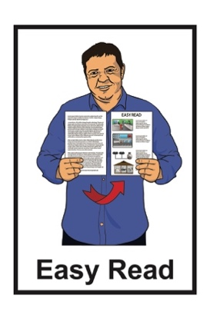

How to register for the Disability Support Services consultation

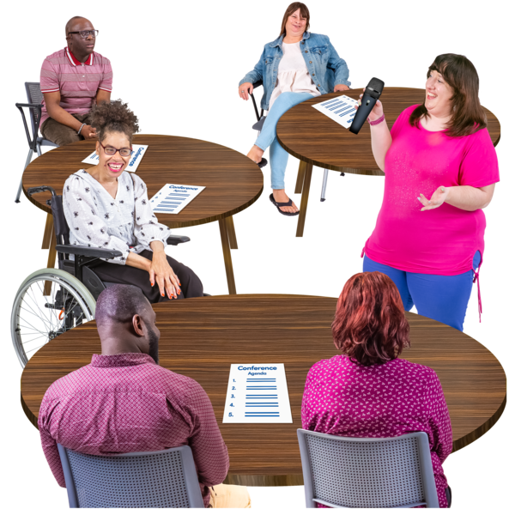

Published: January 2025

# About this Easy Read

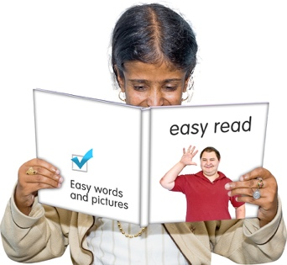

This Easy Read is about how to **register** for community **consultation** **workshops** on Disability Support Services.

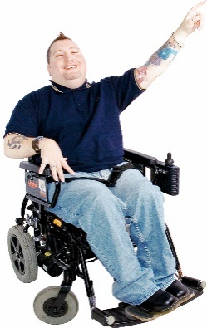

**Register** means to say you want to do something.

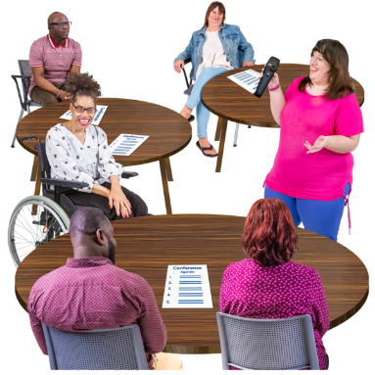**Consultation workshops** are when we:

bring people together in a group

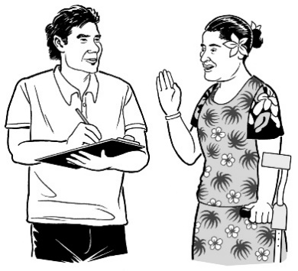talk to people about something important

ask people questions.

In this document **consultation workshops** will be called **workshops**.



You can find out more about the workshops here:

[**www.disabilitysupport.govt.nz/consultation**](http://www.disabilitysupport.govt.nz/consultation)

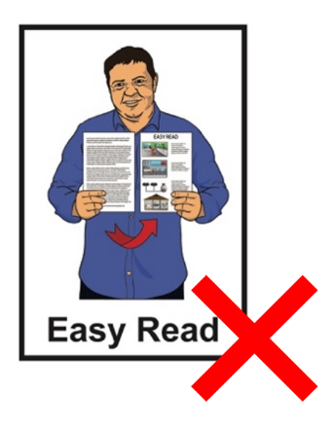

This website is not in Easy Read.

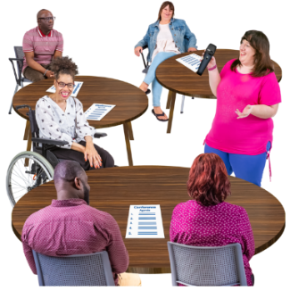The consultation is being run by Disability Support Services with assistance from:

 All is for All

others.



Where it says **we** this means the people running the workshops.

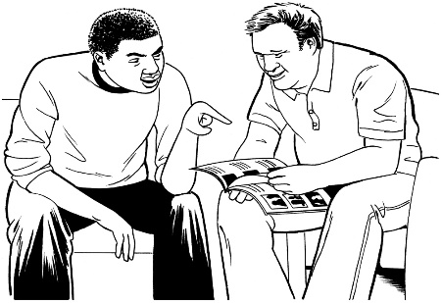You might like to ask a support person to support you to register.

# How do I register?



To register for a workshop you can either:

fill out the form on this **website**:

[**www.research.net/r/dssregistration**](http://www.research.net/r/dssregistration)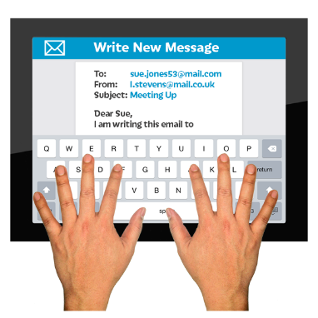

**email**:

**dssconsultation@allisforall.com**

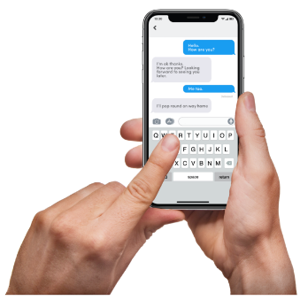**text**:

**021 0841 5035**

**phone**:

**021 0841 5035**

This phone number will cost money to call.

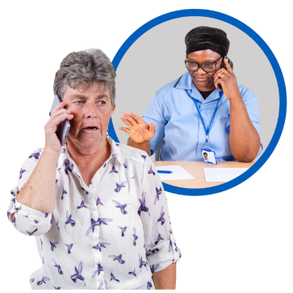If you need support to register you can ask when you:

phone

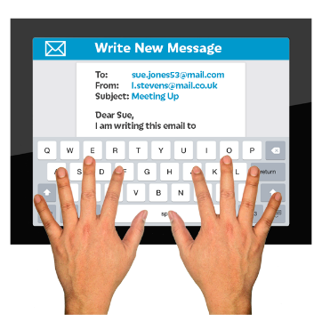or

email.



We will ask you questions when you register.

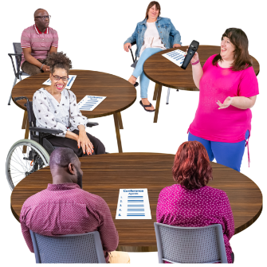

This is so we know which workshop to put you in.

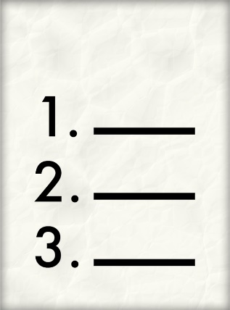We will only ask for the information about you that we need to know.

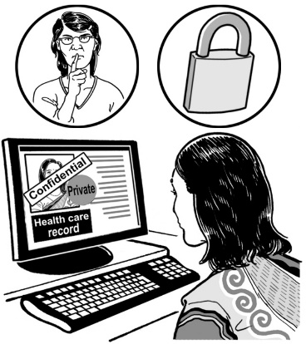The information we ask you for will be:

kept private

seen only by the team organising the workshops.

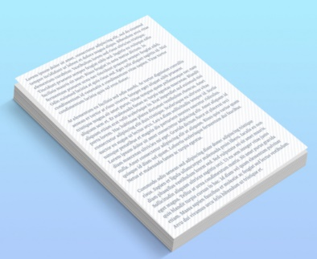We have a privacy statement that tells you more about what we do with information about you.

****The information in the privacy statement is in the form at:

[**www.research.net/r/dssregistration**](http://www.research.net/r/dssregistration)

We are making an Easy Read of the privacy statement which will be added to the form.

The workshops have a limit to the number of people who can come to them.

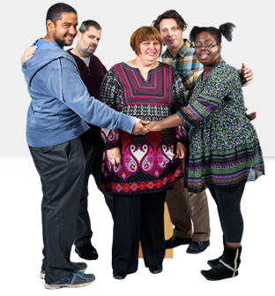This is so that everyone is:

safe

comfortable.



If you register on the website the form will say if a workshop is full.

When you register you will be contacted in 1 day by:

phone

or

email.

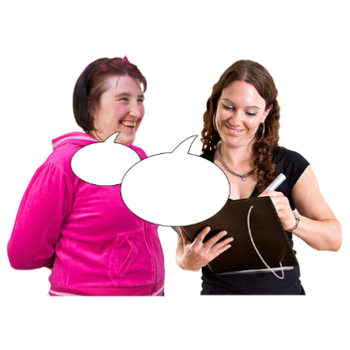This is to tell you the workshop you are going to.

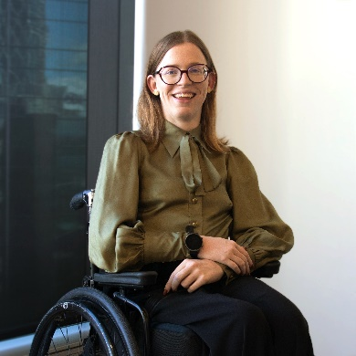The people you will talk to when you register are:

Grace

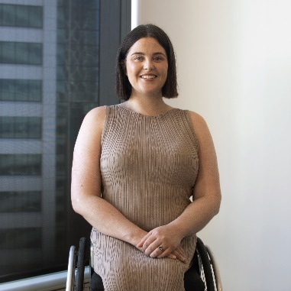or

Rebecca.

# What happens if I am going to an in-person workshop?



We will send you the information about your in-person workshop when you have registered.



This information will be the:

date

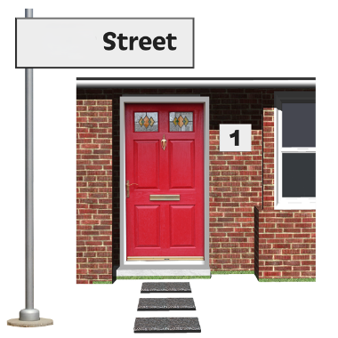time

place.

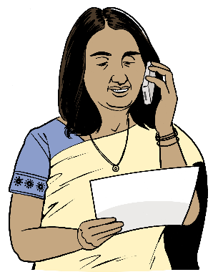We will also remind you about the workshop by:

phone

or

email.

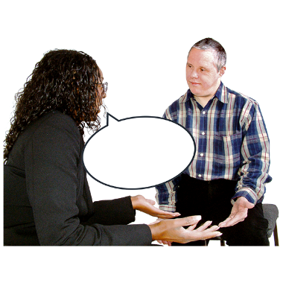

It is important to tell us if you find out you cannot come to the workshop.

If you want to ask us questions you can:

**phone**:

**021 0841 5035**

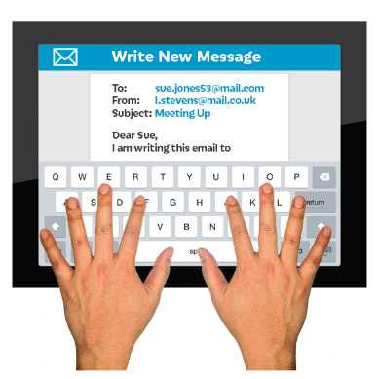**email**:

**dssconsultation@allisforall.com**

# What happens if I am going to an online workshop?



To be part of an online workshop you will need your own device like:

an iPad

a computer

a tablet.

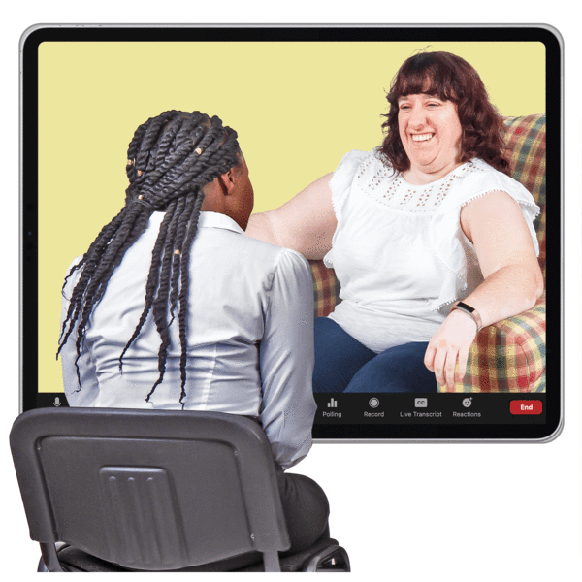

We will use **Zoom** for the workshops.

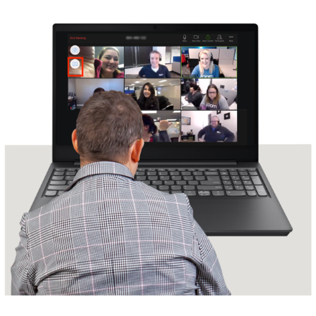**Zoom** is a programme that is used to:

talk to people

show video of the people you are talking to.

We will send you the information about your online workshop when you have registered.



This information will be:

a link to a calendar with the:

* date
* time

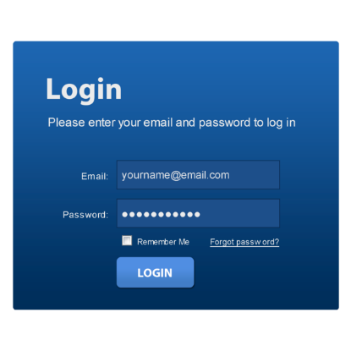a link to the Zoom meeting

how to log in to the online workshop on Zoom

the rules for the workshop.

If you need support to connect to the workshop on Zoom we will give you:

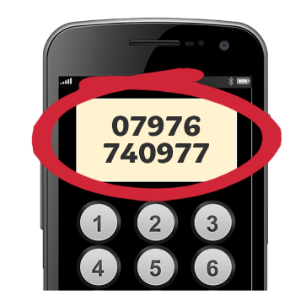an email address

a phone number.

We will also remind you about the workshop by:

phone

text

or

email.

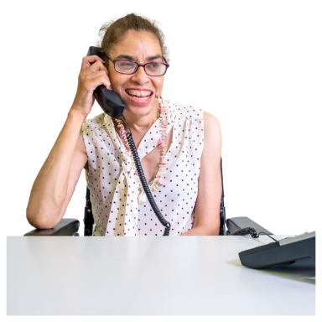If you want to ask us questions you can:

**phone**:

**021 0841 5035**

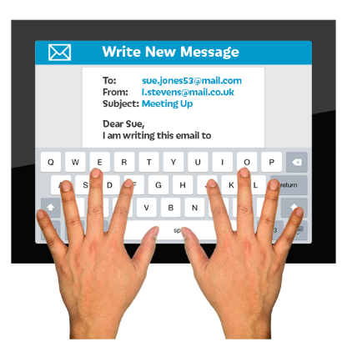**email**:

**dssconsultation@allisforall.com**

# Who will I be talking with at the workshop?

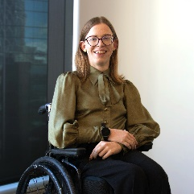The people you will be talking with at the workshop are:

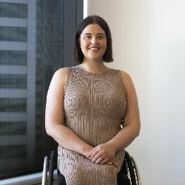Grace

Rebecca

Ben

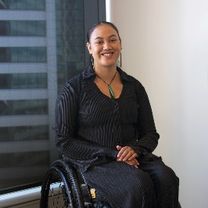Latifa

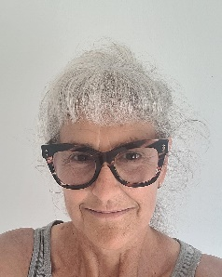Chelsea

Arohanui.

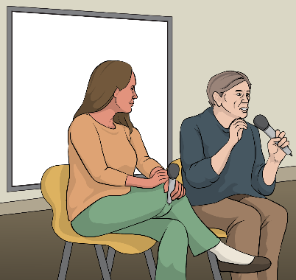There may be other people at the workshop on the day.

We will tell you who they are.

**This information has been written by All is for All.

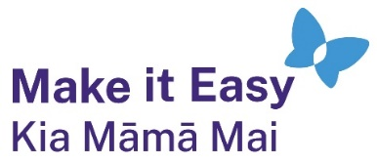It has been translated into Easy Read by the Make it Easy Kia Māmā Mai service of People First New Zealand Ngā Tāngata Tuatahi.



The ideas in this document are not the ideas of People First New Zealand Ngā Tāngata Tuatahi.



All images used in this Easy Read document are subject to copyright rules and cannot be used without permission.

Make it Easy uses images from:

* 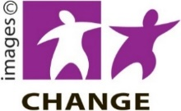Photosymbols
* Change Images
* Huriana Kopeke-Te Aho



* SGC Image Works
* T Wood
* A logo for a school

  Description automatically generatedStudio Rebeko
* Inga Kramer.